Manual Test Plan Week 3

* Weight Animation
  + Both pound and kilo plates should animate when any set button is clicked on
  + The plates should touch but should not overlap in their final positions
  + Weights should be stacked in order of increasing size/weight
  + Double tapping on a set should not animate weights
  + 
* Set Timer
  + Double tapping on a set button should make the set timer information pop-up appear.
  + The times displayed should be consisted, for each set, with the time the user hit the corresponding set button.
  + Set1 should first be set to the time the view loads
  + If a set has not been clicked yet the timer should not display a time for that set
  + The time since last set field should display the number of seconds since that last set was clicked
  + 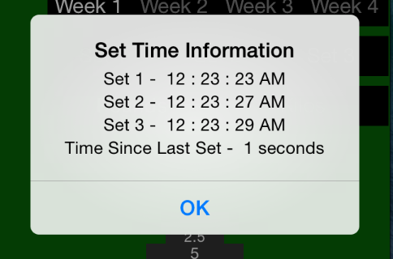
* Record A Lift
  + The user should be able to record a set from the main lift view
  + The last video taken, unless deleted should be loaded into the player when returning to this view even after closing the app
  + The player should not automatically start
  + The player should loop after a taken video is watched
  + The user should be able to share the video via messages, mail and facebook but not twitter.
  + The text the users shares the video with should be auto populated to contain information on the cycle, week, set, weight, reps, date and lift and should contain a link to this app in the appstore
  + 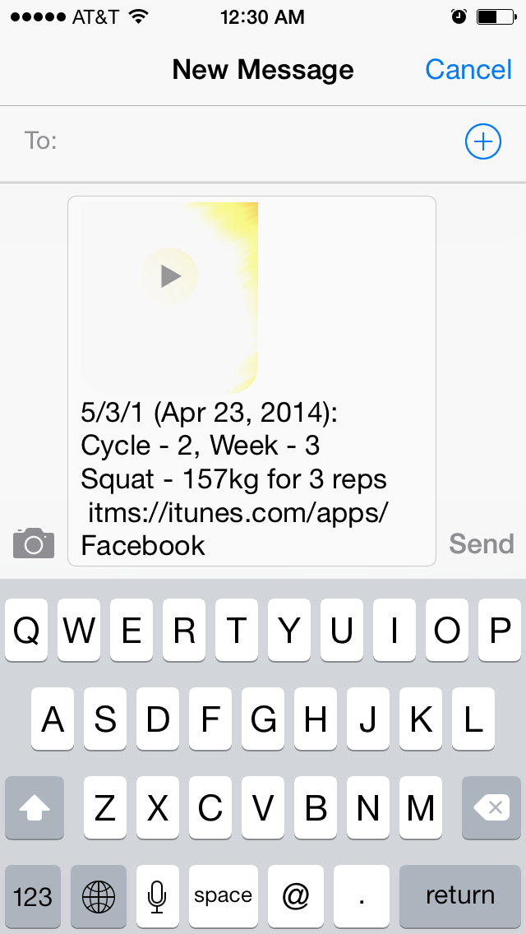
* Advertisements
  + Banner ads should display at the button of every view except the record a lift view on the larger iPhones
  + Banner ads should display at the button of every view except the record a lift view and main lift view on the smaller iPhones
  + Banners should not interfere with any of the pages’ content or ever prevent the user from entering input
  + 